**Probability and Statistics (UCS410)**

**Experiment 4: Mathematical Expectation, Moments and Functions of Random Variables**

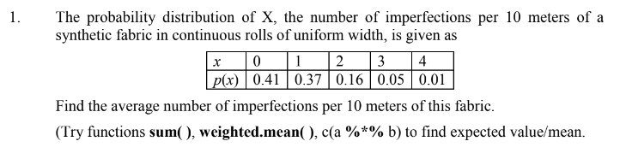**CODE (using weighted.mean( )):**

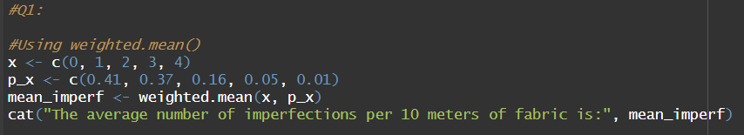

**OUTPUT:**

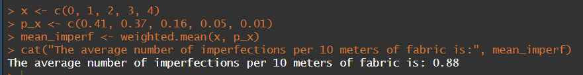

**CODE(sum()):**

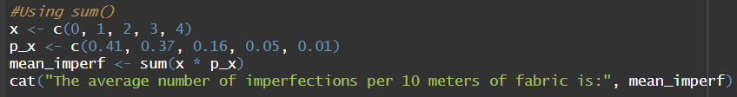

**OUTPUT:**

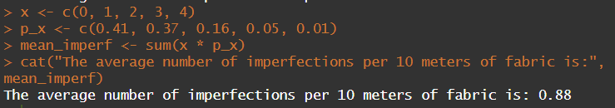

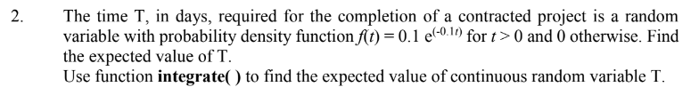

**CODE:**

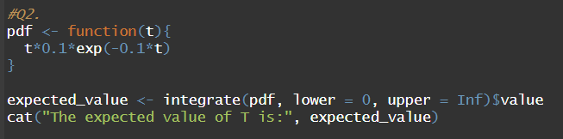

**OUTPUT:**

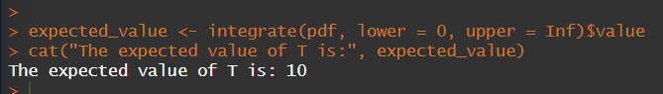

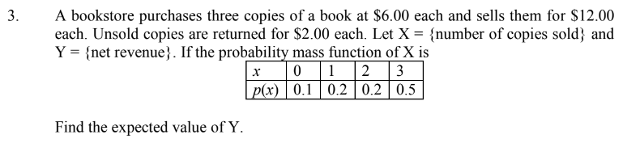**CODE:**

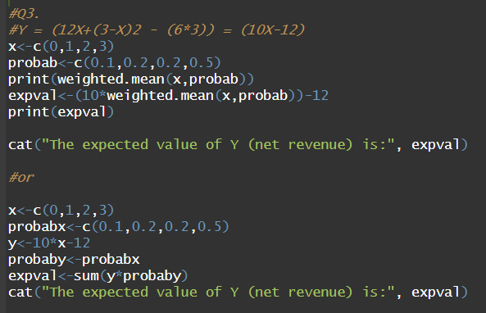

**OUTPUT:**

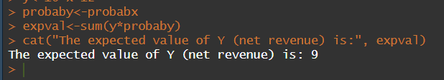

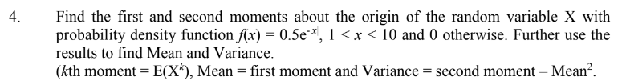

**CODE:**

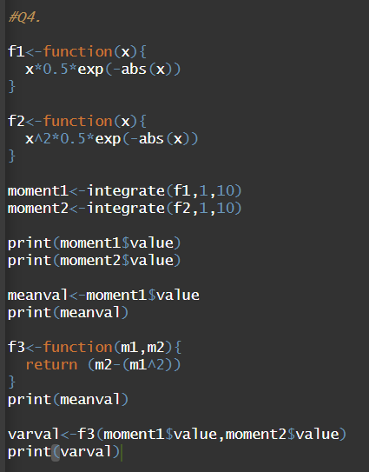

**OUTPUT:**

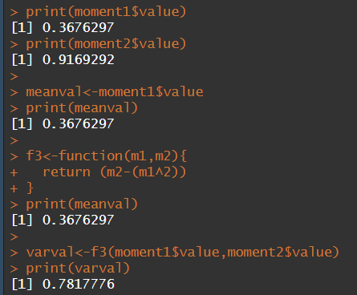

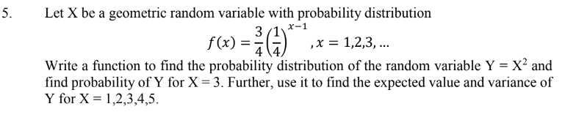

**CODE:**

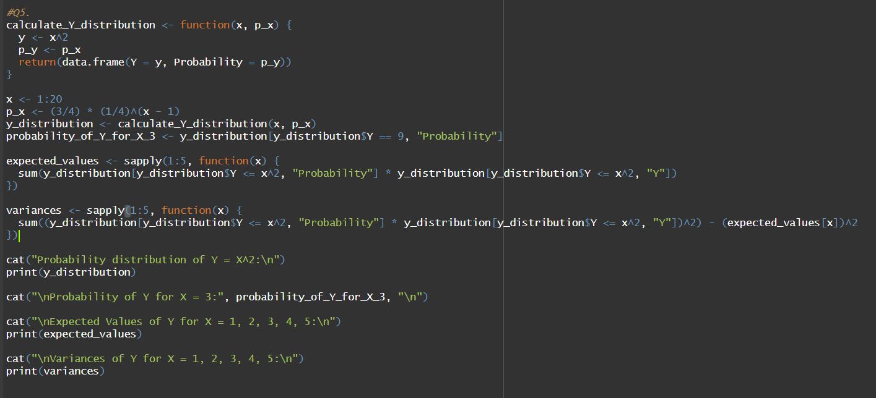

**OUTPUT:**



